Dear Pastor and church, “Grace be unto you, and peace, from God our Father, and from the Lord Jesus Christ. I thank my God upon every remembrance of you, Always in every prayer of mine for you all making request with joy, For your fellowship in the gospel from the first day until now;” (Phil. 1:2-5)

I can’t help but feel a sense of familiarity with Paul’s salutation to the believers in Philippi. For sure, when I think of those who faithfully pray for, and support us, I thank God for them. I am thankful to serve the Lord, and realize that I could not do so, at least in the capacity I am now able, were it not for your support. I only wish I could report to you that we are seeing people saved and added to the church regularly. We do continue to have new, and returning visitors periodically, and we have had several reach out after seeing some of our “advertising.” Recently, a man entered the auditorium about midway through the Sunday School hour. After SS, I went to him and welcomed him. He asked, “Who are you?” I apologized and told him my name and that I was the pastor. He said, “But, who are you.” I told him I was just a sinner saved by grace. We talked for another minute or two. He said, “Well, I met who I needed to” shook my hand, wished me a “good day” and left. I will admit, I was a little uneasy during the rest of the morning services. I told the church, “I am not sure” what that was all about” and to pray for the man.

To try and answer how we were feeling, we had the parsonage tested for mold, and learned that there were elevated levels in parts of the house. We have to take care of a few issues prior to addressing the mold issue, and are working on those things now. Lord willing, we will have the mold remediation work done some time in early July. Thank you to those who have sent special offerings to assist in this expense.

In May, the Lord blessed us with our eleventh grandchild. Our daughter Mikayla and her Husband Ricky are now the proud parents of Richard Wilder Knipp. We praise God for this wonderful gift.

At the writing of this letter, my mother has once again been admitted into the hospital. The doctor stated, “She is not on death’s door, but she is declining rapidly.” Mom is saved, “tired” and ready to go home to be with her LORD. Your prayers on her behalf are greatly appreciated.

My son, Kristopher, who pastors in Raleigh, NC, took a group of young people to camp in June. When he arrived there, he learned that one of the counselors this year was a young men he “counseled” ten years ago. (I have included a photo below). I share this to remind us, myself especially, that although we do not always see immediate fruit from our labor, we can expect to see fruit in God’s time. Justin Deeter offers these words of encouragement: “Though God might not always work in an immediate, drastic, and unexpected way, the word of God does not return void, but bears fruit according to God’s sovereign plan… we must let the word of God do its work in our people. In season and out of season, proclaim the Gospel of Christ to your congregation. Preach with fiery boldness and admonish with tears, trusting in the Spirit to bring life. Perhaps it will take months, years, or decades. Perhaps we may never see the tangible fruit of our ministry within our own lifetimes. Yet, may the message of the Gospel ever be on our lips, and may we ascend to our pulpits each week anew, believing with all of our hearts that this could be the week where the Spirit brings those dry bones to life.” To this I say, Amen, and May the Lord help me to be faithful, fully trusting in His Word, His Spirit, and His timing.

May God grant unto all of us the desire, the strength, and the power of the Holy Spirit to remain faithful in the great work we are privileged to have a part.

Thank You! for your continued prayers and support.

Pastor Michael Wilder

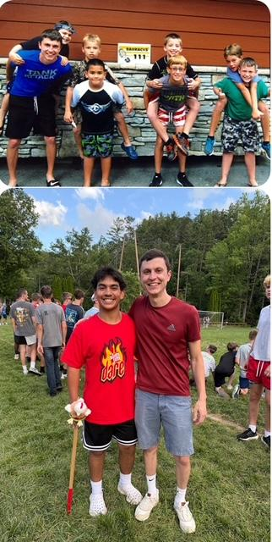

The boy to the left of Kristopher in the top photo is the young man with him in the lower photo.
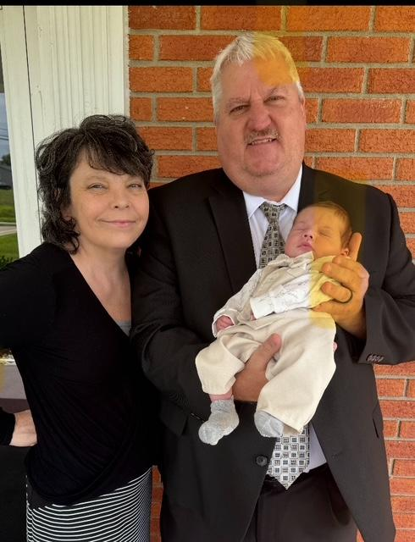

My lovely wife, myself, and Wilder, our 11th grandchild.

Monthly Church Support 2nd Quarter

April May June

Berry BC, Berry, KY $200.00 $200.00 $200.00
Bryan Station BC, Lexington, KY $950.00 $950.00 $950.00
New Testament BC, Burton, OH $400.00 $400.00 $400.00
Winton Place BC, Cincinnati, OH $100.00 $100.00 $100.00
Pleasant Ridge BC, Lexington, KY $200.00 $200.00 $200.00
Mt. Pleasant BC, Chesapeake, OH $100.00 $100.00 $100.00
Brentwood BC, Roanoke, VA $200.00 $100.00 $100.00
Flat Rock MBC, Flat Rock, MI $200.00 $100.00 $200.00
Bible BC, Ghent, NY $ $70 $70.00

Total: $2350.00 $2050.00 $2390.00

M.L. Wilder
Pastor, Trinity Missionary Baptist Church
2300 Lexington Road
Richmond, KY 40475
606-465-3097

