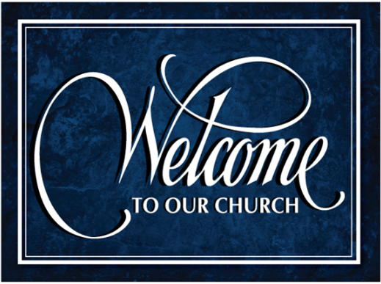

Welcome and thank you for joining us today! It is our sincere prayer that the service this morning will be a blessing & encouragement to you. If you have any questions, please reach out to our pastor or one of the ushers.
September 7, 2025
Welcome, Opening Comments & Prayer Requests

Hymn #13 Crown Him With Many Crowns

Handshake & Greet One Another

Hymn #517 I Am Resolved

Offering & Prayer for Our Country

Hymn #1527 Majesty

Hymn #1383 Glorify Thy Name

Message: Philippians 3:1 Pastor Jeff Brown

Closing Prayer ~~~~~~~~~~~~~~~~~~~~~~~~~~~~~~~~~~~~~~~~~~~~~~~~~~~~~~~~~~~~~~~~~~~~~~~~~~~~~~~~~~~~~~~~~~~~~~~~~Church Copyright License #22241673


CCLI Streaming License #22241680
~~~~~~~~~~~~~~~~~~~~~~~~~~~~~~~~~~~~~~~~~~~~~~~~~~~~~~~~
Shane Ross Brittany Mesue Aaliya Mesue
150 Brent Lane 150 Brent Lane 150 Brent Lane
Box 2249 PO Box 904 PO Box 1175
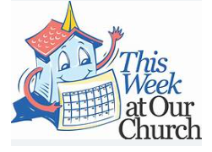
Pensacola, FL 32507-2267 Pensacola, FL Pensacola, FL

~~~~~~~~~~~~~~~~~~~~~~~~~~~~~~~~~~~~~~~~~~~~~~~~~~~~~~~~~~~~~~~~~~~~~~~~~~~~~~~~~~~~~~~~~~~~~~~~~~~~~~~~~~~~~~~~~~~~~~~~~~~~~~~~~~~~~~~~~
- Wednesday Morning Bible Study @ 10 AM
- Wednesday Prayer Meeting @ 7 PM
- Ladies Fellowship, Saturday, September 20,rt from 10-11 in the fellowship hall. See Allene for more information
- On Sunday, September 28, we will have an all-day service. Our Morning Worship will be followed by a Fall Harvest Potluck lunch & the Lord’s Supper. See Sandy Haemmerlein (618-929-4466) or Teresa (329-201-0396) for more information.
- Fall Fest at Sallee & Peter Dunton’s house on October 4 @ 12noon. It will be a Potluck. (51 Berkshire Ridge, Canaan).

~~~~~~~~~~~~~~~~~~~~~~~~~~~~~~~~~~~~~~~~~~~~~~~~~~~~~~~~~

For those having trouble hearing the service, please use a hearing device or, if you have a telecoil (T-foil) hearing aid, a neck loop is available for your use. Please see the sound booth to get yours.
~~~~~~~~~~~~~~~~~~~~~~~~~~~~~~~~~~~~~~~~~~~~~~~~~~~~~~~~~~~~~~~~~~~~~~~~~~~~~~~~~~~~~~~~~~~~~~~~~~~~~~~~~~~~~~~~~~~~~~~~~~~~~~~~~~~~~~~~~
Missionaries We Support:
- Capital City Rescue Mission - Albany, NY
- Columbia Christian Academy - Ghent, NY
- Daniel Ferrito - India
- Richard & Leah Jacobs - Nashville, TN
- Jason & Senya Mann - Macedonia
- Daniel & Tiara Pearson - Kennedy Heights, Cincinnati, OH
- Juan & Melissa Sante Fe - Bogata, Columbia
- Michael & DeAnna Staley - US Military - Rota, Spain
- Mike & Tina Wilder - Richmond, KY
- Koffi & Elizabeth Wodome - Togo, West Africa

~~~~~~~~~~~~~~~~~~~~~~~~~~~~~~~~~~~~~~~~~~~~~~~~~~~~~~~~~~~~~~~~~~~~~~~~~~~~~~~~~~~~~~~~~~~~~~~~~~~~~~~~~~~~~~~~~~~~~~~~~~~~~~~~~~~~~~~~~~~~~~~~~~~~~~~~~~~~~~~~~~~~~~~~~~~
This year, we are collecting Items for Samaritan’s Purse Christmas Shoeboxes. Boxes will be provided, along with instructions on`` what to put in them. We are asking for $10 shipping fee. Please see Sallee Dunton for more information.


To have a prayer request added or taken off the list, please text Anita B. @ 518-653-5121
Cancer
Julie Olstead David Dobson Jennifer Helferich Sarah W. Lori Sterritt’s niece, Camilia
Carrie B. Chris Sayers Leon (Joy’s friend)
Doug Griffin Jay Sterritt Carmen Tedder Rick
John Porecca Dawn Porecca Johanna Mann Adams

Health/Healing:
Sallee Dunton Maggie Moisan Edith Wagner
Elliot Cooper Jeff Sterritt Melissa Metrando
Ruth Pulcher Barbara Metrando Steve M. (Sallee’s neighbor)
Peter Dunton Dena Maoriana Faith Metrando Peter Schlegel Shirah Gleason Matt Metrando
Melodie Potter Justin Pulcher Joan Wheeler Karl Kuhnen Annie Kate

Salvation/Spiritual Condition:
Devin Badertscher Eric Samperisi Jr. & children
Jim Craig Mary C. (Rand’s client)
Duane Lyon Chris & Karena (Spears) Blaurock
Zach Cole Tom Every
Patty Brown Jamie B.

Military/Public Servants:
Judge John Porecca Greg & Johanna Horst Travis VanAlstyne
Trooper Jerrard W. Alex Horst Toby VanAlstyne
Julia Horst Andrew Horst Ryan Ingram (pastor’s nephew)

Mourning Lost Loved Ones:
Ruth Pulcher & family Ryan & family - loss of wife/mom
Balish family Moisan family Paul & family - loss of wife/mom

Misc. Prayer Requests:
Ooms family & decisions about Dini’s care
Our church family & visitors
Columbia Christian Academy Barbara Metrando - unspoken
Julie & Jessie - Allene’s co-worker
Our Nation, First Responders & Police Joan Wood & family

Bible Baptist Church
website: bbcghent,com
youtube: @BibleBaptistChurch-Ghent
Pastor Jeff Brown: 518-878-2290 (cell) Anita: 518-853-5121 (cell)

