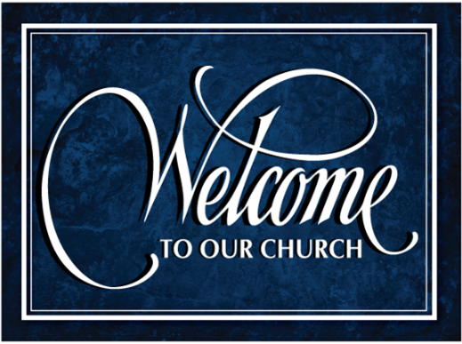


Welcome and thank you for joining us today! It is our sincere prayer that the service this morning will be a blessing & encouragement to you. If you have any questions, please reach out to our pastor or one of the ushers.
July 6, 2025
Welcome, Opening Comments & Prayer Requests

Hymn #779 National Anthem

Hymn #780 My Country ‘Tis of Thee

Hymn #781 America the Beautiful

Scripture Reading: Mark 9:42-50

Offering & Prayer for Our Country

Scripture Reading: Mark 10:1-12

Hymn #784 I Believe in Miracles

Hymn #666 My Jesus I Love Thee

Message & Scripture Text: Genesis 3:1 Pastor Jeff Brown

Closing Prayer

~~~~~~~~~~~~~~~~~~~~~~~~~~~~~~~~~~~~~~~~~~~~~~~~~~~~~~~~~~~~~~~~~~~~~~~~~~~~~~~~~~~~~~~~~~~~~~~~~~

Church Copyright License #22241673

CCLI Streaming License #22241680

~~~~~~~~~~~~~~~~~~~~~~~~~~~~~~~~~~~~~~~~~~~~~~~~~~~~~~~~~

Wednesday Bible Study @ 10 AM
Wednesday Prayer Meeting @ 7 PM

~~~~~~~~~~~~~~~~~~~~~~~~~~~~~~~~~~~~~~~~~~~~~~~~~~~

Mailing address: Shane Ross
Pensacola Christian College
150 Brent Lane
PO Box 2249
Pensacola, FL 32503-2267

~~~~~~~~~~~~~~~~~~~~~~~~~~~~~~~~~~~~~~~~~~~~~~~~~~~~~~~~~

For those having trouble with hearing the service please see the sound for a hearing device or if you have a telecoil (t-foil) hearing aid we have a neck loop you can use.
~~~~~~~~~~~~~~~~~~~~~~~~~~~~~~~~~~~~~~~~~~~~~~~~~~~~~~~~~~~~~~~~~~~~~~~~~~~~~~~~~~~~~~~~~~~~~~~~~~~~~~~~~~~~~~~~~~~~~~~~~~~~~~~~~~~~~~~~~
Missionaries We Support:
- Capital City Rescue Mission - Albany, NY
- Columbia Christian Academy - Ghent, NY
- Daniel Ferrito - India
- Richard & Leah Jacobs - Nashville, TN
- Jason & Senya Mann - Macedonia
- Daniel & Tiara Pearson - Kennedy Height, Cincinnati, OH
- Juan & Melissa Sante Fe - Bogata, Columbia
- Michael & DeAnna Staley - US Military - Rota, Spain
- Mike & Tina Wilder - Richmond, KY
- Koffi & Elizabeth Wodome - Togo, West Africa

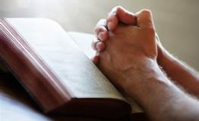
To Have a prayer request added or taken off the list please call/text Anita B. @ 518-653-5121

Cancer
Julie Olstead Tina Wilder David Dobson Jennifer Helferich Michael Austin Sarah W. Lori Sterritt’s niece Camilia Carrie B. Chris Sayers Leon (Joy’s friend) Denise Broadwater Doug Griffin Jay Sterritt Carmen Tedder Rick John Porecca Dawn Porecca Johanna Mann Adams

Health/Healing:
Sallee Dunton Maggie Moisan Edith Wagner
Elliot Cooper Jeff Sterritt Melissa Metrando
Ruth Pulcher Barbara Metrando Steve M. (Sallee’s neighbor)
Peter Dunton Dena Maoriana Faith Metrando Peter Schlegel Shirah Gleason Matt Metrando
Justin Pulcher Joan Wheeler Annie Kate

Salvation/Spiritual Condition:
Devin Badertscher Eric Samperisi Jr & children
Jim Craig Mary C. (Rand’s client)
Duane Lyon Chris & Karena (Spears) Blaurock
Zach Cole Tom Every
Patty Brown Jamie B.

Military/Public Servants:
Judge John Porecca Greg & Johanna Horst Travis VanAlstyne
Trooper Jerrard W. Alex Horst Toby VanAlstyne
Julia Horst Andrew Horst Ryan Ingram (pastor’s nephew)

Mourning Lost Loved Ones:
Ruth Pulcher & family Bruce Lyon family
Tammy Hazelwood Moisan family

Misc. Prayer Requests:
Our church family & visitors Joan Wood & family
Columbia Christian Academy Barbara Metrando - unspoken
Julie & Jessie - Allene’s co-worker Shane Ross - working@ PCC camp
Our Nation, First Responders & Police
Christians being persecuted around the world

Bible Baptist Church
website: bbcghent,com
youtube: @BibleBaptistChurch-Ghent
Pastor Jeff Brown: 518-878-2290 (cell) Anita: 518-853-5121 (cell)

